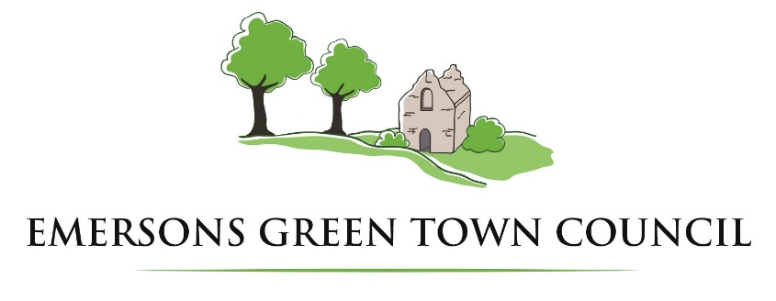
Grant Application Form
Emersons Green Town Council awards grants to be used for the benefit of the local community. The Council must ensure that due diligence is undertaken when awarding grants it is therefore important that all applicants ensure that all information is made available at the time of submission. If this is not the case then please explain why. The submission of an application indicates that you agree to the terms and conditions on the last page of the form.

Name of Organisation
Address of Organisation
Name of contact person
Position within the organisation
Email address of contact person
Telephone number of contact person

What does your organisation do?
When was your organisation formed
Is your organisation a registered charity? If yes include the registration number. | Yes / No  Registration Number:
Are you submitting a copy of your Constitution or Terms of Reference? If not please explain why. | Yes/No
Is your organisation part of or affiliated to a national organisation? If Yes please give details. | Yes/No

Please describe the project and how it will benefit the community.

How many people within the Town Council Boundary will benefit from the project? (Boundary Map attached to this application form)
Age 0 – 18
Age 19 - 59
Age 60 and over

Which category are you applying under (see terms and conditions for explanation)
Older People
Younger People
Arts & Culture
Sports & Recreation
Highways & Transport
Environmental Enhancement
Charitable and Advice Organisations
Organisation supporting minority groups

What is the total cost of the project | £
If over £3,000 have you obtained 3 quotes? If not please explain why. | Yes/No
How much of your own funding will you be using for the project? | £
What is the size of the grant you are seeking from EGTC? | £
Have you previously received a grant from EGTC? If yes how much and when? | Yes/No  £
Have you applied for other grants, if so to whom and for how much. | Yes/No  £  Organisation:

Please include any other information that you feel will support your application

Should your application be successful please include details of the organisations Bank Account, the latest copy of the bank statement should be supplied.
Name of Account
Name of Bank
Address of Bank
Sort Code
Account Number
Number of Signatories required to authorise payments | 1 / 2 / 3 / 4

Declaration
By signing and submitting this application I agree that I have read and accept the terms and conditions and that I have answered all questions fully and truthfully.
I acknowledge that Emersons Green Town Council will be recognised on any materials produced and in any form of publicity as a result of this grant.
I acknowledge that Emersons Green Town Council may request further supporting documentation or invite representatives to Town Council meetings prior to making a decision.
The following paperwork is attached/enclosed:
- Application form in full Yes/No
- Constitution/Terms of Reference Yes/No
- Copies of Quote/s Yes/No
- Copy of latest Bank Statement Yes/No
- Copy of last Audited Accounts Yes/No
- Any other supporting documents Yes/No

Signed: ………………………………………………………………… Name: ………………………………………………………………..
Postion: ……………………………………………………………… Date: ………………………………………………………………….

Emersons Green Town Council
Grant Application Terms & Conditions
Emersons Green Town Council (EGTC) is empowered to award grants to benefit the community as follows:
- Older People (over 60) – to maximise opportunities for independent living and to provide support and assistance when deemed appropriate
- Younger People (0-18) – To support a wide range of activities to empower young people and meet their social, education or leisure needs
- Arts & Culture – To support community involvement in local arts and cultural activities and to promote cultural services which benefit the Town of Emersons Green
- Sports & Recreation – To support community participation in local sports and leisure activities and to enable clubs to develop and improve the sporting infrastructure
- Highways & Transport – To facilitate access and sustainable transport schemes by community and voluntary activity and to promote cycling schemes
- Environmental Enhancement – To improve the environment of Emersons Green and enrich its heritage/resources/biodiversity and to sustain community life
- Charitable and Advice Organisations – Organisations which offer advice free of charge and charitable organisations that are of the benefit to Emersons Green residents
- Organisations supporting Minority/Disability Groups – Organisations that offer support to people from minority or disability groups within Emersons Green
Applications will not be considered from:
- Individuals
- Organisations intending to support or oppose any particular political party or to discriminate on the grounds of race, age, gender, disability, sexual orientation or religion
- Religious organisations to promote religious faith – applications can be considered where the project produces a clear support to the community irrespective of religious beliefs
- Private Organisations operating as a business to make profit or surplus funds
- Local groups whose funding is sent to a central organisation for redistribution
- The Council will not normally consider the funding of specific staff roles
The Town Council considers grants throughout the year. Applications are considered by the Finance Committee and ratified by the Full Council. Applicants may be asked to provide more information about a project or to attend a meeting prior to a decision being made.
Successful applicants will need to submit a report to the Council within 12 months of the grant being awarded including a financial report on the project and how the grant from the Town Council was used. The Town Council reserves the right to claim back unused grant funding or that not used for the purpose for which it was awarded.
By submitting an application you are accepting the Council will process your data in line with its General Privacy Notice and agreeing to these Terms & Conditions.
